Prompts for Activity 3 – Fractal Dimension

For each of the following fractals, find a magnification and count the number of self-similar pieces to then calculate the fractal dimension.
If you want an extra challenge, try at least two different magnifications to make sure you get the same fractal dimension.

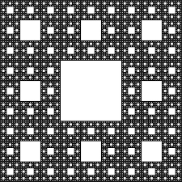
N=# Self Similar Pieces: ______________

M=Magnification: ______________

D=ln(N)/ln(M): ________________
Sierpinski Square

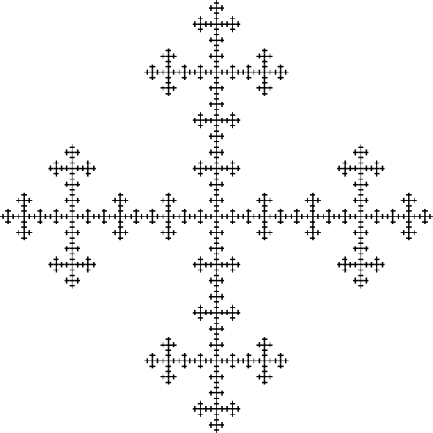
N=# Self Similar Pieces: ______________

M=Magnification: ______________

D=ln(N)/ln(M): ________________

Box Fractal

Bonus Problem!

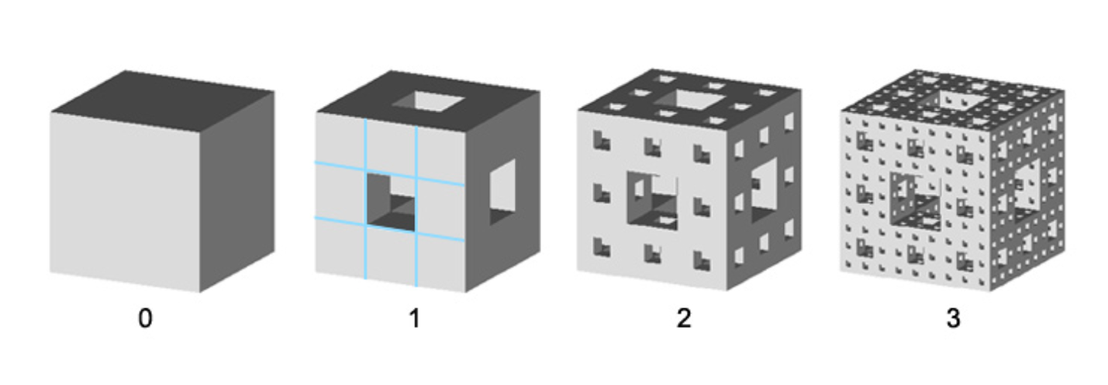

Use the image above showing the construction of the Menger Sponge to find its fractal dimension.

N=# Self Similar Pieces: ______________

M=Magnification: ______________

D=ln(N)/ln(M): ________________

